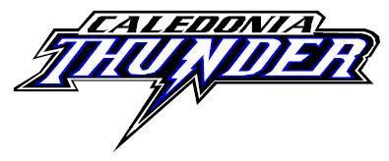

CDMHA Board Meeting Report: 8 January 2024

Present: Kelly Riley, Michael Kichinko, John Kichinko, Roger Long, Mark Annett, Nicole Samson, Paula Hamilton, Katie Gravelle, Jeff MacDonald, Traciann Fisher, Erin Noble, Mark Harrop, Ashley Stoneman
Regrets: Leanne Tinebra, Arli Harrison
Absent:
Late:
Left Early:
Members:

Meeting Called to Order: 6:29 pm

Meeting Chair & Time Keeper: Traciann Fisher, President

Agenda & Meeting Minutes: Secretary
- Motion to accept January 2024 meeting agenda by; Mark Harrop
Seconded by; Nicole Sansom
- Motion to accept December 2023 meeting minutes by; Erin Noble
Seconded by; Kelli Riley Motion Carried.
Errors and Omission:

Reports:

Ice Scheduler’s Report – John:
- Practice schedule has been updated to January 14
- All teams (U11 to U15) have been scheduled for at least 4 full ice practices to January 14
- All Haldimand LL regular season games to be completed by January 14
- Revised Challenge Cup schedule completed
- U13 Playoff schedules posted on website
- U11 split is done waiting on Cayuga to do schedule, U15 should be done tomorrow and U18 will more than likely go to the last day
- Spring Ice Request Discussion - submission due February 1 – we will ask for 15 hours of spring ice at this time.
- Waiting for the playoff schedules for all the divisions before we can put in the U7 practices – we would guess that they will get the 5 pm Friday time slot.

Registrar’s Report – Mike:
- No Report Issued

VP Report – Erin:
- U9 are full ice as of 14 January 2024 and will be using the Ipad and are doing full ice games

Minor Novice/IP Convenor/Coordinator Report – Katie:
- U6 coach had approached and asked about playing a “fun” game at the end of the year – they would like to invite Hagersville

Development Convenor Report – Mark:
- Goalie development is done – there is interest
- There is still player development until February
- In the past, we never let anyone use the black dividers or the small nets and it was noticed that they were being used for private development – this will need to be addressed as these are for use for CDMHA only.

Coach Development Convenor Report – Roger:

No Report Issued

Equipment Manager’s Report – Leanne:
- U13 team 1 needs a white board

Time Keeper Convenor Report – Mark H:
- No Report Issued

Treasurer’s Report – Jeff:
- See Annex A.
- Non-Profit By-Laws – Lawyer to look at our Constitution/P&P to ensure that they are up to par.
- Need to purchase ink cartridges for the printer – this will run us approx.. $500

Website – Arli:
- No Report Issued
Challenge Cup – Mark H:
- 8 teams in each division except for U13 (7) they wil play two games and that will determine the seeding
- We did not get complaints about the schedule – we got positive feedback
- One Kitchener Team still needs to hand in their travel permit
- Theresa will schedule the time keepers for Cayuga and we will use their IPads.
- Gong Show hats have been purchased for shut outs – they will be picked up in Caledonia
- Please come over to the arena and help out if you can either with Registration or anything else that Mark needs help with.

Convenors –:
- In Camera 7:52 pm Out of Camera 8:01 pm

Fundraising –:
- No Report Issued

Secretary Report – Traciann:
- No Report Issued
- Awards for next year – ordering of ESSO medals and something else

President Report – Traciann:

- Will be convening a discipline committee - to meet after this meeting.
- Will need to put out the award nominations for next month to get them back in time for awards. Does someone want to take charge of this?
- The next meeting is 5 February 2024 in the ReMax Room

Open Business:

- Action: River Kings
- Discussion: Please ask about a convenor for Caledonia

- Action: April 17th for the AGM
- Discussion: Will look at the date to see if it is available

- Action:
- Discussion:
New Business:

- Action:

- Discussion:

Action: Discussion:

- Action:
- Discussion:
E-Mail Votes

There were no email votes.
Deferred from last Meeting:

Deferred to Next Meeting:

Motion to adjourn by: Roger Long
Seconded by; Nicole Sansom
Motion Carried

Meeting Adjourned 8:16 pm

Annex A
Financials - October

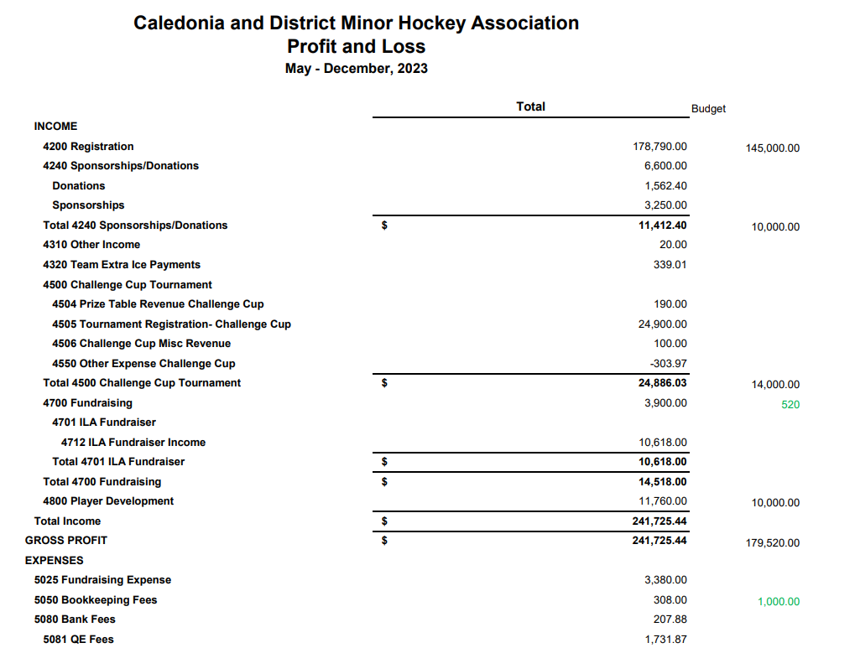
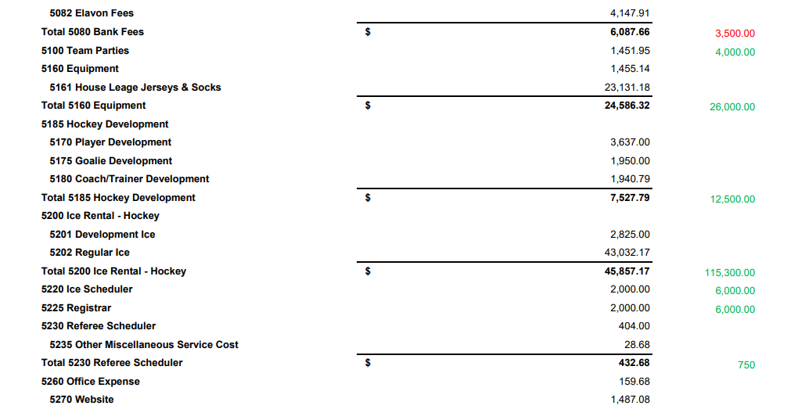
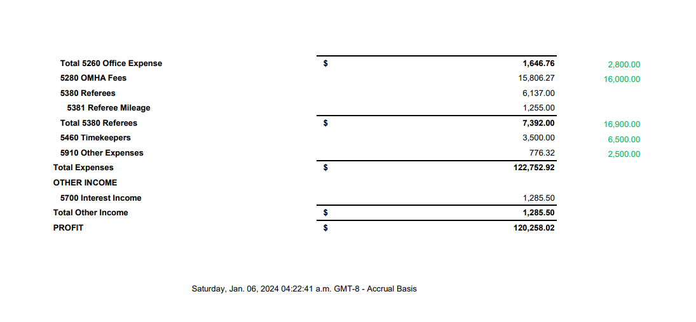

Annex A
November Financials

Financials for December 2023
Opening Balance: $150,585.04
Income: $14,929.25
- Registration - $2185.00
- CC Reg - $8,900.00
- Fundraising - $140
- Sponsorship (OMHA, Miller Funeral, Scotiabank) - $3200.00
- Ref Clinic Payment - $141.25
- Timekeeper Payment - $93.00
- CC Table Revenue (Previous Year) - $190
- Plan Rebate - $80

Expenses: $31,119.31
- SportsPay/Elavon – $555.96
- Other Expenses - $28.69
- Refs/Assigner/Mileage - $3526.00
- Timekeepers - $2260
- Cheques, 10 total - $4246.90
- Ice for November - $20,226.08
- Cheque Reorder - $159.68
- Plan Cost - $80

Closing Balance: $134,394.98

